KENTON COUNTY FAIR
COWBOY MOUNTED SHOOTING
HOSTED BY THE KY COWTOWN RANGERS
Must see Event!!!
Cheer them on!!!
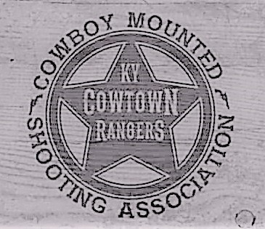
SATURDAY, JULY 20, 2024
REGISTRATION 6:00 P.M. SHOW START 7:00 P.M.
$75.00 TOTAL ENTRY FEE $500.00 ADDED!!!!!!
MUST BE A CMSA MEMBER TO PARTICIPATE
WWW.CMSAEVENTS.COM
RIDER & HORSE
AGAINST THE CLOCK & BALLOONS!!!!
3 STAGES OF PISTOL
2 STAGES OF SHOTGUN
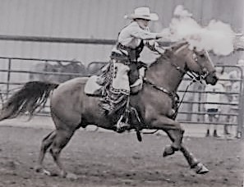

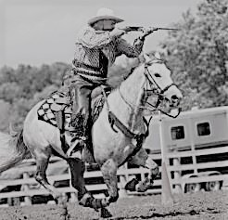
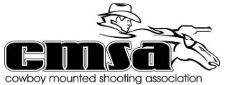
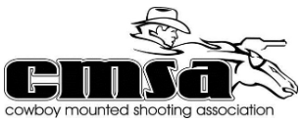
KY COWTOWN RANGER CONTACT:
STEVE SPENLAU 859-743-7438
DIVISIONS
MEN/SR MEN LEVEL 1 & 2
MEN/SR MEN LEVEL 3 & 4
MEN/SR MEN LEVEL 5 & 6
LADIES/SR LADIES LEVEL 1 & 2
LADIES/SR LADIES LEVEL 3 & 4
LADIES/SR LADIES LEVEL 5 & 6

